joshua roberts

Design documentation

Project outline

Contents

Website design 2

Features and functions 2

Test specification 2

Site map 3

Mood board 4

Wire frame 5

# Website design

The task that we were given is to create a website for a small local club. The website that I will create will include a home page, fixtures page, welcome page, course page, membership page, contacts page and clubhouse page. The club that I will create my website on is the Sutton bridge golf club they currently have a website however the layout and the choice off colours make the website very hard to understand and gather the information required. [Sutton Bridge golf club](http://www.club-noticeboard.co.uk/suttonbridge/index.php)

## Features and functions

Curtain menu

Columns

Links to go to other web pages

## Test specification

1. Home page

Will include curtains menu so the user can go to the other web pages

Will include a picture gallery to show off the course

1. Fixture page

Will include all upcoming competition with the date and teams involved

1. Membership page

Will include how much a round of golf is and how much a yearly membership will cost for an adult and a child

Will have an external link so the user can fill out a copy

1. Contacts

Will show the user who to contact, where to find the golf course and display a map

Will also have all higher board members email and phone number

## Site map

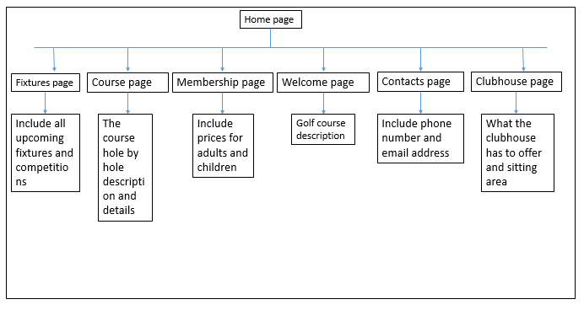

## Sutton Bridge Golf Course | Golf Course in SPALDING | Golf Course Reviews & Ratings | Today's GolferSutton Bridge Golf Club | Lincolnshire | English Golf CoursesMood board

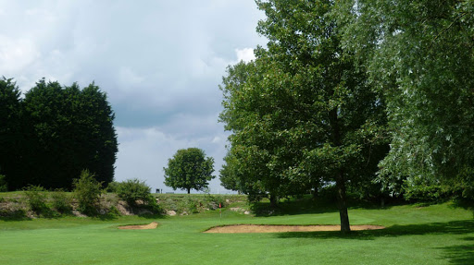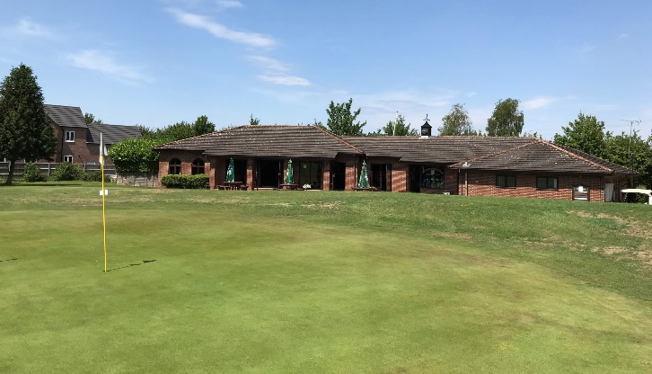

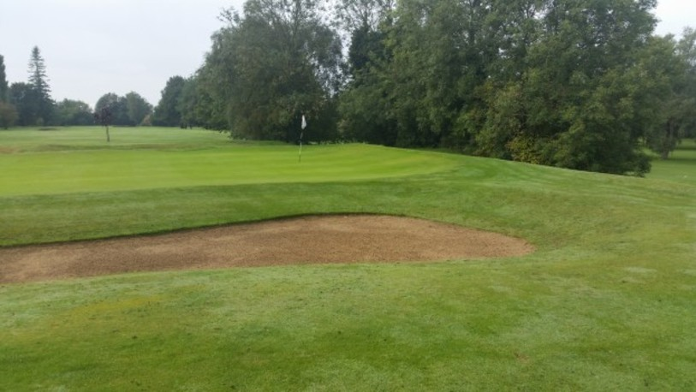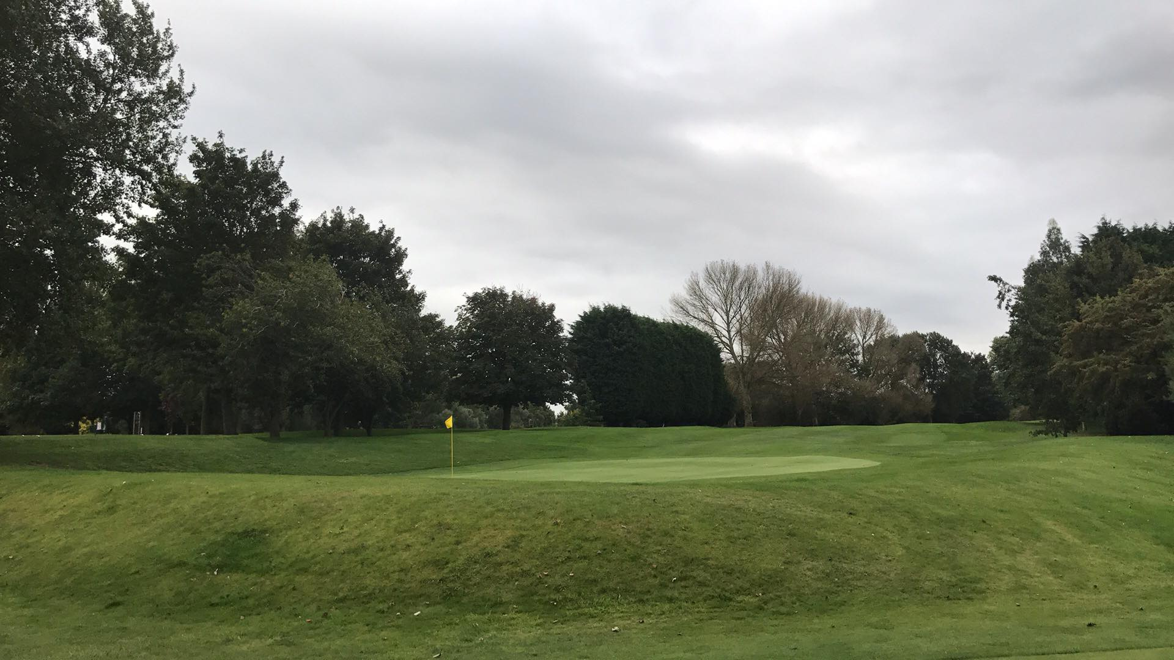

## Wire frame

Desktop view

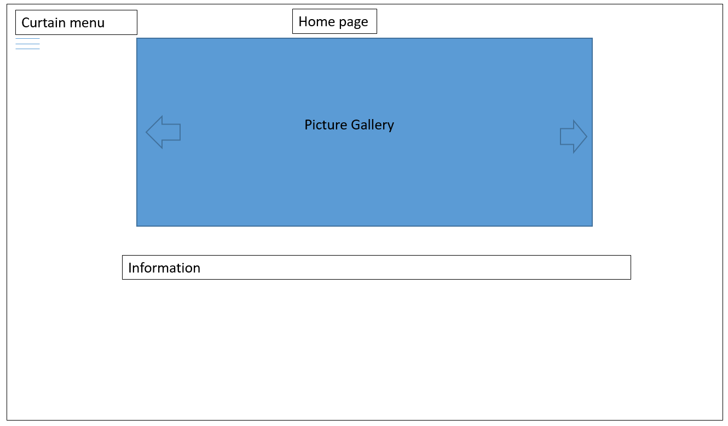

Mobile phone

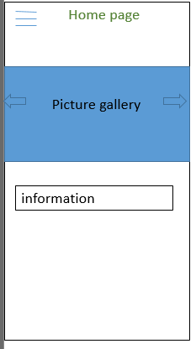

JavaScript will be used to create the picture gallery as shown above in order to display the amazing pictures of the golf course and its clubhouse.